Correlation analysis – notes

Disclaimer: Correlations coefficients span from -1 to 1 (1 implies a strong positive correlation; 0 implies no correlation; -1 implies a strong negative correlation) and are tested for statistical significance at the 5% level. The time horizon of this analysis is constrained to 2016’s WW1 through WW39 (Q1-Q3). The goal of this analysis will be to tie strong positive correlation to campaign media metrics and our client’s onsite user behavior.

* Digital Footprint (Search + Social + Display)
  + Digital media becomes more positively and significantly correlated with Paid MQLs over time
    - Exposure to media in market solicits a stronger response over time than immediately, or within the same week. MQL’s from the current week have more of a relationship with digital spend and impressions from prior weeks.

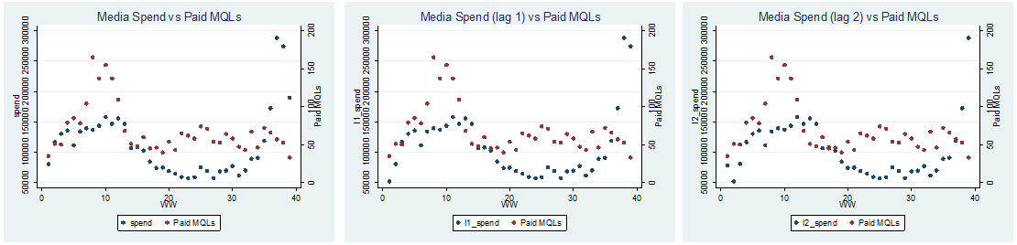

* + Organic MQLs have a weakly negative correlation with Digital Media
    - Digital media spend has largely trended downward (over the year) while organic MQLs have loosely been on the rise. I say loosely because there is no clear visual pattern from week to week.



* Search
  + Paid Search positively correlated with Paid MQLs in real time
    - Because of the continual optimization and decided intentions of a user in the search channel, the correlation is strongest and most significant in real time. Over time, the strength and significance of the correlation diminishes (as seen if we lag media metrics). This relationship could be an indication that paid search is primarily the “closing channel” (vs. “assisting channel”) for conversions.



* Social
  + Paid social is also positively correlated with paid MQLs to a significant degree. The similar trending of both series underscores the influence of social advertising. It could be posited that the reach of social media is closely tied to MQL volume. As impression levels dipped in WW 13-14, MQLs followed.



* Display
  + No correlation with MQLs evident in real time or residually. However, display spend and clicks are strongly and significantly correlated over time.



* Side note: Channel correlations with organic MQL performance was similar to digital on the whole, negative or none. I think this is attributable to search being the lion share of the client’s budget. Above 60% per week on average. Because paid search is at odds with organic, the relationship is to be expected.